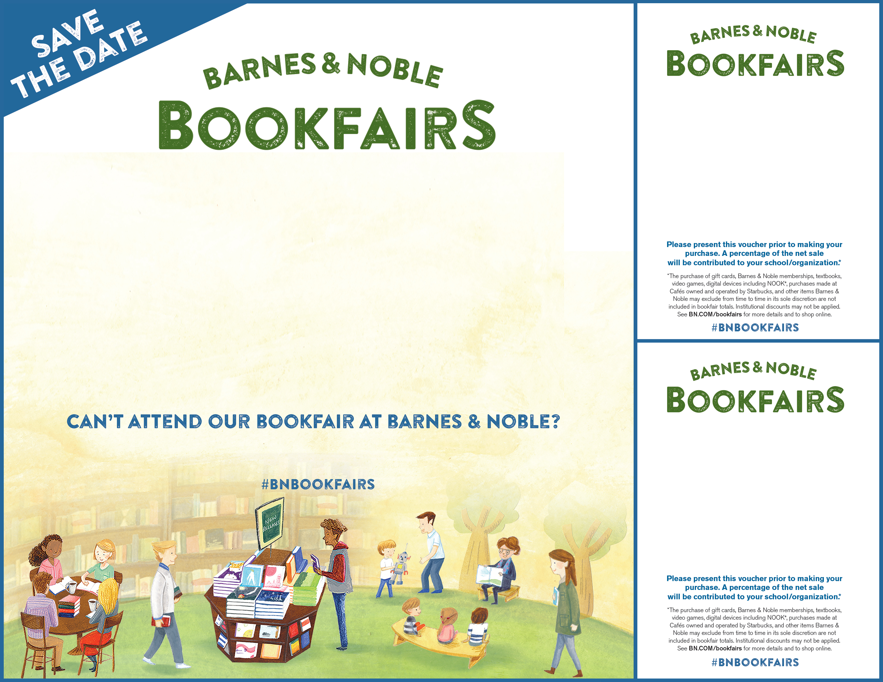
Teasley Elementary
Tuesday December 5th 2017
4:00 -7:00 pm
Barnes & Noble Cumberland

Please join us for our special story times, chorus performance, and art show!

Visit BN.COM/bookfairs to support us online from 12/05/17 to 12/10/17
by entering Bookfair ID 12275327 at checkout.
Tuesday December 5th 2017
Barnes & Noble Cumberland
2952 Cobb Parkway
Bookfair ID 12275327

supporting
Teasley Elementary

supporting
Teasley Elementary

Tuesday December 5th 2017
Barnes & Noble Cumberland
2952 Cobb Parkway
Bookfair ID 12275327

